
NORTH YORKSHIRE EAST FEDERATION APRIL 2025

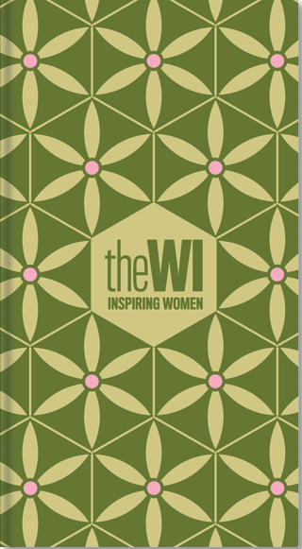
2026 WI DIARY ORDER

For the first time ever, the WI Diary 2026 cover will have a print rather than a solid cover (please see mock-up artwork; the final version will have the year added.) The cover is completely recyclable, making the entire diary recyclable except for the ribbon.

The price of the diary will be the same as the previous year and remain at £7.00 each.

Please complete the form and return it to WI House, Front Street, Norby, Thirsk YO7 1BG as soon as possible but by 29th July at the very latest – diaries will be available for collection at the Autumn Council Meeting, otherwise postage will be charged.

Please make sure that you send your application form accompanied by a cheque to WI House or email your form and confirm date of BACs Payment to financesec.nyefwi@btconnect.com

.......................................................................................................................................................

NORTH YORKSHIRE EAST FEDERATION APRIL 2025

2026 DIARY ORDER

WI.......................................................................................................................

Secretary............................................................................................................

Address ….........................................................................................................

...........................................................................................................................

Number of DIARIES required at £7.00 each .................................. = £.....................

 I enclose a cheque for ................. (Payable to NYEFWI)

 I have paid by BACs…………… Date of BACs Payment ……………..

Signed .................................................................... Date .................................

Please return to WI House, Front Street, Norby, Thirsk YO7 1BG as soon as possible but by 29th July 2025 at the latest. Please make sure that you enclose a cheque made payable to NYEFWI with this form or if paying by BACs, email the order form and confirm payment to financesec.nyefwi@btconnect.com

Registered Charity No 1185965

