FEDERATION CAROL SERVICES


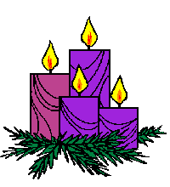

SATURDAY 7TH DECEMBER, ST MARY’S CHURCH, THIRSK,10.30am
SATURDAY 14TH DECEMBER, SELBY ABBEY, SELBY, 10.30am

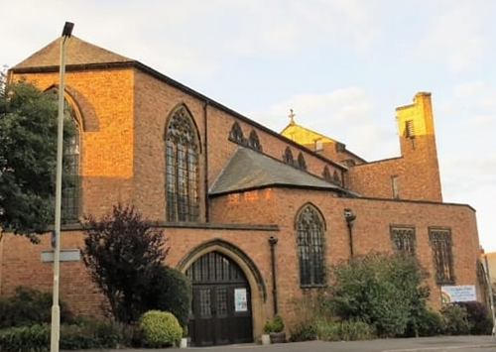
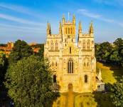
SATURDAY 14TH DECEMBER, ST COLUMBA’S CHURCH, SCARBOROUGH, 10.30am

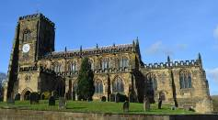

THESE SERVICES ARE A TICKET ONLY ADMITTANCE

Please tick the venue you are applying for below and make sure you return this form to WI House, Front Street, Norby, Thirsk YO7 1BG as soon as possible, by 7th November 2024 at the very latest, bearing in mind that tickets will be allocated ON A FIRST COME, FIRST SERVE BASIS and may have been allocated before the closing date. FRIENDS AND FAMILY WELCOME.

Please do not forget to enclose a Stamped Addressed Envelope as this is a ticketed event.

……………………………………………………………………………………………………………………………………………….

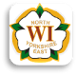
FEDERATION CAROL SERVICES



WI ……………………………………………………………………………………….

WI Contact ………………………………………………………Tel. No. …………............................................

Address …………………………………………………………………………………………………………………

…………………………………………………………………………………………………………………………..

Email ……………………………………………………………………………………………………………………

Please tick Chosen Venue
St Mary’s Church, Thirsk (Code 759) 
Selby Abbey (Code 759) 
St Columba’s Church, Scarborough (Code 759) 

No of tickets required …………………

Signed …………………………………………… Date …………………………………

Please complete the tear off form and return to WI House, Front Street, Norby, Thirsk YO7 1BG as soon as possible but by 7th November 2024 at the very latest. Please ensure a STAMPED ADDRESSED ENVELOPE is enclosed with each application form.

Charity Commission Reg. No. 1185965

Please note that all events are undertaken at your own risk

